**TASK-04**

Mass & Weight

**EXPLANATION:**

The program asks the user to enter mass of a body and calculates its weight and if the weight is more than 1000 then a message prints that the weight is too heavy and if its less than 1000 N then a message prints saying that its too light.

**INPUT:**

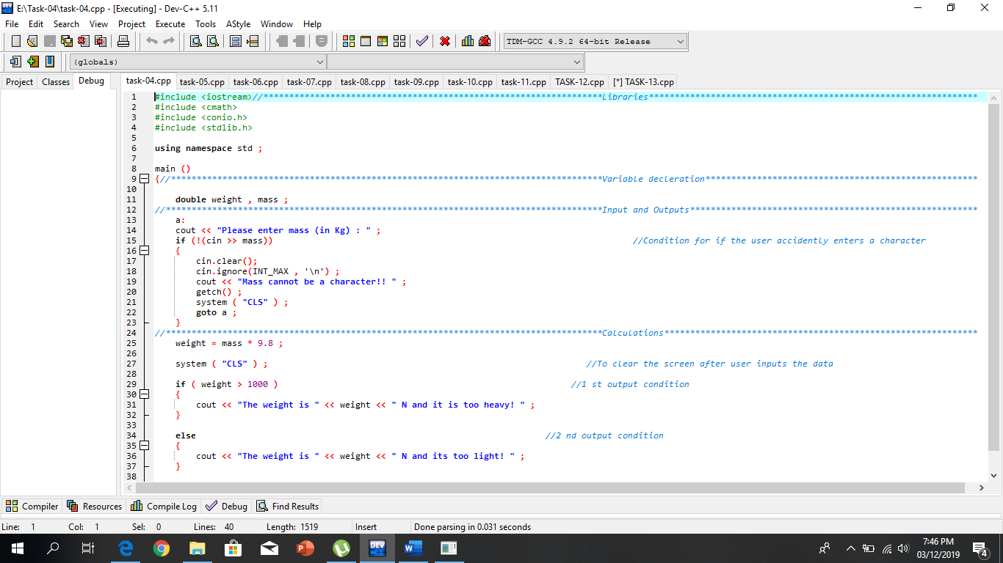

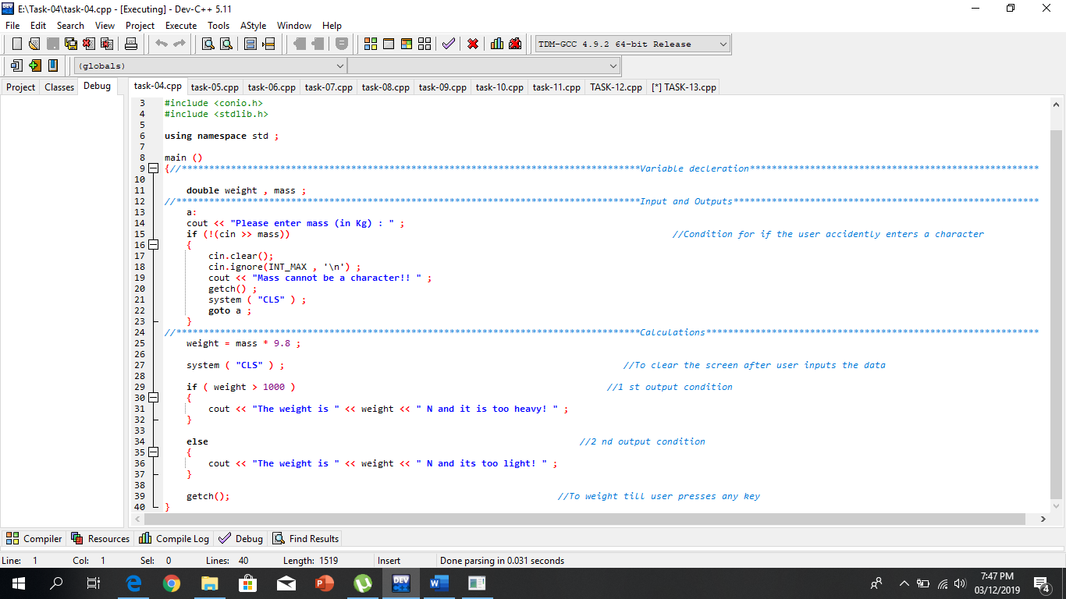

**OUTPUT:**

